Contents
1 Introduction 3
1.1 Purpose and Scope 3
2 Design Overview 3
3 Process and Threading Model 5
4 Design considerations and limitations 6
4.1 Concurrent SWI operations 6
4.2 Backups 6
4.3 TCB Boundary 6
4.4 TrustedUI Capability and SWI 6
4.5 Synchronous/Asynchronous mode of operation 6
4.6 Cancellation 6
4.7 Non-native applications support 6
4.8 Preinstalled applications on Removable Media 7
4.9 PC Connectivity 7
4.10 Content delivery 7
5 Detailed Design 7
5.1 Client UI Implementation 8
5.1.1 Overview 8
5.1.2 UML Diagram 9
5.1.3 AsyncLauncher vs. Launcher 9
5.2 UI Support Server 10
5.2.1 Overview 10
5.2.2 UML Diagram 10
5.2.3 Design Unit Behaviour 10
5.3 SWI Daemon 11
5.4 SWI Server 12
5.4.1 Overview 12
5.4.2 UML Diagram 13
5.4.3 Design Unit Behaviour 14
5.5 SWI Planner 14
5.5.1 Overview 14
5.5.2 UML Diagram 15
5.6 SWI Processor 15
5.6.1 Overview 15
5.6.2 UML Diagram 16
5.7 SIS Launcher 17
5.7.1 Overview 17
5.8 Security Manager 17
5.8.1 Overview 17
5.8.2 Design Unit Behaviour 18
5.9 SISHelper Server 18
5.9.1 Overview 18
5.9.2 Design Unit behaviour 19
5.10 Data Provider Framework 19
5.10.1 Overview 19
5.10.2 UML Diagram 19
5.10.3 Design Unit Behaviour 19
5.11 Integrity Support 20
5.11.1 Overview 20
5.11.2 Design Unit Behaviour 20
5.12 OCSP Support 20
5.12.1 Overview 20
5.12.2 Diagram 21
5.12.3 Design Unit Behaviour 21
5.13 SisRegistry 21
5.13.1 Overview 21
5.13.2 UML Diagram 22
5.13.3 Design Unit Behaviour 22
5.13.4 SisRegistry and Secure Backup 24
6 Scenarios 24
6.1 Cancelling an Installation 24
6.2 Uninstallation 25
7 Further Information 26
7.1 References 26
7.2 Glossary 26

Introduction

Purpose and Scope
This document describes the design of the Software Install component (SWI) of the security subsystem. The purpose of this document is to describe high-level interactions and design of SWI.
The intended audience of this document is the members of the Security Team.
The reader should be familiar with platform security concepts requirements, as described in [R2] and [R5]. This document expands on the high level description of SWI in [R3].

Design Overview
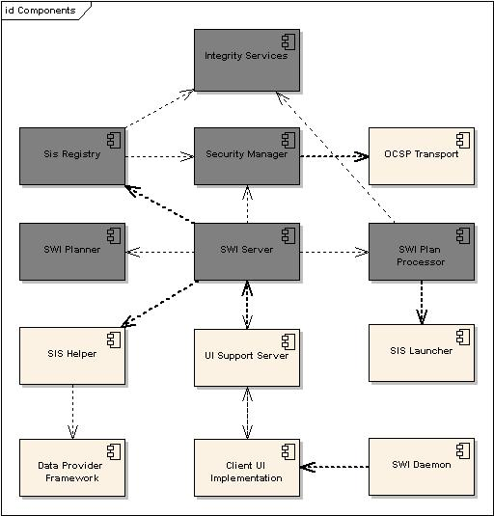
Figure 2-1 Components’ Design Overview
In Figure 2-1 Components’ Design Overview we can see a high level view of SWI (REQ2681). In the diagram we distinguish between components in and out of TCB. Components in TCB are greyed. Interfaces which cross process boundaries are shown in bold.
SWI contains a number of subcomponents. Here we shall give a brief description of their functionality, and in the following sections we shall describe their overall interaction and design in more detail.
- Client UI Implementation
Implements the user interface for the installation process. Currently implemented user interfaces include UIQ, S60, Techview, PC-driven installation, command line installation utility and script adaptors for automatic testing.
- UI Support Server (UISS)
The UI support server provides a link between client UIs implementations and the SWI TCB component. It achieves two design goals: secure communication from and to the TCB, and abstraction of the client UI for the SWI Server. Since a component in TCB cannot call a function on a component outside TCB: the interaction must be performed using IPC, which is provided by the UISS.
- SWI Daemon
Monitors removable filesystems for changes. If a media with installable files is inserted, it invokes the installation process.
- SisHelper (REQ2681.2)
Provides a parser to translate a SISX file into an object representation which is used by the rest of the SWI components. For security reasons, it is implemented as a server which delivers application data to the TCB side of SWI.
- Data Provider Framework
Provides data access services and abstractions for SISHelper. Provides a DRM-enabled implementation, Consists of several components, which provide a DRM-enabled implementation, licensee-customized implementation and regular file system access implementation. For the sake of clearness is displayed as one in the diagram.
- SWI Server (aka SWIS, TCB) (REQ2681.3)
The SWI Server serves as the mediator for the software install/uninstall/restore process. It implements the main state machine, and coordinates between all the participating components.
- SWI Planner (TCB)
The SWI planner is created by the SWI Server. The planner is subclassed for the install, restore and uninstall operations. Its duty is to build a plan for the needed operations on the filesystem and the registry. During this processing the planner interacts with the UI (using the UI Support Server) to retrieve information from the user, e.g. installation drive, installation language, etc. Once the plan has been completed it is handed back over to the SWI Server.
- SWI Plan Processor (TCB)
The SWI Plan Processor is also created by the SWI Server. It is subclassed for the different operations supported by SWI. It accepts from SWI the plan prepared by the Installation Planner. It validates the SISX signatures using the Security Manager. It performs the planned operations on the filesystem and the registry using the Integrity Services.
- SisLauncher
This component is used by the Plan Processor to run files during install / uninstall. Has power management capability to allow it to terminate applications.
- Integrity Services (TCB)
Provides recovery and rollback services for both graceful and non-graceful cancellations of SWI operations. Installation/uninstallation/restore can be cancelled both manually by the user (graceful), and due to phone shutdown (non-graceful). In all cases, the phone should be able to return to consistent state.
- SisRegistry (TCB)
The SisRegistry is a server which keeps information on installed applications. It provides this information to the installation planner and external clients. It has TCB due to the need to write to the /sys directory. It also uses Integrity Services to maintain its database in the filesystem.
- Security Manager (TCB)
The Security Manager is a helper component which provides security services for the rest of SWI and for SisRegistry. Its duties include file hashing, hash verification, capability checking, signature validation and OCSP checks.
- OCSP Support Server
The OCSP Support Server provides OCSP support to the Security Manager. OCSP checks rely on HTTP connectivity; consequently the OCSP support server cannot reside in TCB.

Process and Threading Model
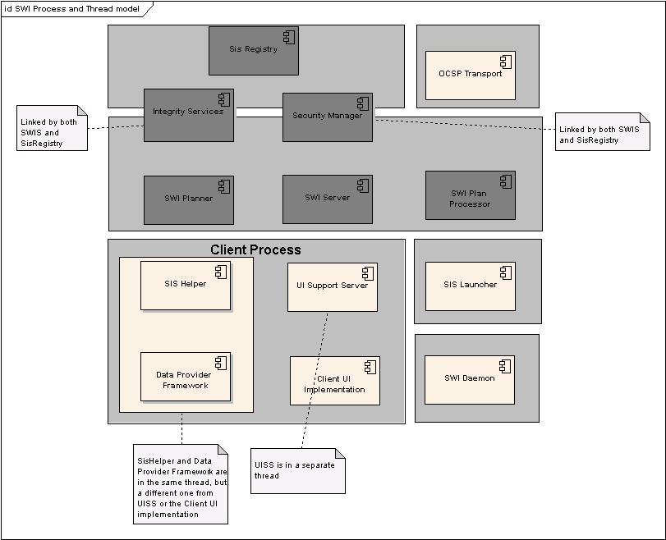
Figure 3-2 Processes and threads in SWI
Figure 3-2 Processes and threads in SWI displays the processing and threading model in SWI. All greyed areas represent separate processes.
- UISS, SisHelper and Client UI Implementation all reside in a single process. Client UI Implementation runs in the thread which is used to launch the SWI operation.
- SWIS and SisRegistry are not multi-threaded, and all components run in the same thread.
- SWIS and SisRegistry reside in TCB, which is clearly visible in the process model.
- IntegrityServices and SecurityManager are TCB DLLs which are linked by both SisRegistry and SWIS.

Design considerations and limitations

Concurrent SWI operations
Concurrent installations\uninstallations\restores are not supported by the system. UISS Server, SISHelper are named servers, and can exist only in one copy at any time in the system. UISS Server serves as a gateway for this limitation and returns KErrBusy if a concurrent operation is attempted.

Backups
Backups are implemented using a separate mechanism. Secure Backup Client accesses SisRegistry via dedicated API calls to receive the data needed for backup.

TCB Boundary
The SWI Server needs the TCB capability by definition, as it is the entity which can grant capabilities to others, and create new runnable executables in the OS (REQ2681.3.2). All components which are not necessary for these operations are put outside of the TCB, and thus, outside of the SWI Server.
In addition to that consideration, TCB processes cannot use most DLLs (as they are less trusted, see [5]), and thus, for example, SISHelper (which make use of decompression libraries), and OCSP Service (which makes use of communication services), cannot be part of the TCB.

TrustedUI Capability and SWI
SWI Server uses the TrustedUI capability to police possible installation clients. So that installation won’t be launched by an untrusted application, all requests to SWI are required to have the TrustedUI capability.

Synchronous/Asynchronous mode of operation
SWI operation can be launched in either synchronous or asynchronous mode. The distinction is implemented at the User Interface Support client-side. In the case of synchronous mode, the call does not exit until the operation completes. In the case of asynchronous mode, an active object is created to accommodate the asynchronous events from UISS. (See section 5.1 and specifically, 5.1.3)

Cancellation
User may cancel a SWI operation at any time. In this case the server terminates the installation/uninstallation thread and performs the necessary housekeeping (REQ2681.5), which includes removal of any newly copied files and restoration of the files that were overwritten or deleted during the operation. The device is essentially restored to the state it was in just before starting the cancelled operation. (See section 6.1)
Although SWIS accepts a cancellation request at any time, it finishes the current task before honouring the request.

Non-native applications support
SWI framework supports only native applications, which excludes all applications which run in a virtual execution environment, such as Java Midlets. The consideration is that the execution environments implement their own security model, which includes the installation process.
There is a possibility of uniting both native and non-native installations under the same framework in the future.

Preinstalled applications on Removable Media
SWI is required to handle preinstalled applications delivered on removable media. The user can simply insert the removable media and expect the application to work.
To make this possible SWI must be notified of media insertion/removal and check the integrity of its content. For additional details, see section 5.3.

PC Connectivity
Installations and uninstallations can be launched from the PC side. In the PlatSec world, all user prompts during said operations may appear only on the phone, as PC UI cannot be trusted. Thus, the flow of such operations is:
- The data (for an installation) is streamed from PC to phone storage.
- When enough data is available, recognizers are launched. This allows providing an early feedback to the user of the file is of an unsuitable type.
- Installation/uninstallations is launched at the phone side and all the dialogs are displayed on the phone.
- The PC Connectivity phone-side component monitors Publish-and-Subscribe flag which signals when the operation is finished.

Content delivery
At the moment SISX files can be installed in two ways. The file can reside on the device (SWI will just read the file in this case) or be installed from the PC. The SWI architecture provides a layer of abstraction over the content delivery to allow for different strategies, e.g. the SISX file could be streamed from the PC requiring much less space on the device. This is achieved by introducing the data provider abstraction (see section 5.10). If the SISX file must be copied to the device prior to installation, we would need, in the worst case, twice the amount of space required by a streaming implementation.
This simple abstraction layer allows us to easily expand the content delivery mechanism to cater, e.g., for streamed OTA content.

Detailed Design
In this section we shall delve deeper in the design of the individual SWI subcomponent. We will then describe their interactions.

Client UI Implementation

Overview
In Figure 5-3 Installation sequence diagram we can see a sequence diagram representing the high-level installation sequence.
The process is initiated by an installation client which may be the phone UI, the PC connectivity tool or any other agent with the proper clearance. The software install client is required to have TrustedUI capabilities. The installation client uses the Install() method of the static class Swi::Launcher to initiate the installation process. The Install() method takes as parameter a UI callback implementation (implementing the Swi::MUiHandler mixin, see Figure 5-4 UI Call-back Mix-In) and a mechanism to access the SISX content. The method is overloaded to provide for different content delivery mechanism, e.g.
Install (Swi::MUiHandler& aUiHandler, const TFileName& aFileName)
Install (Swi::MUiHandler& aUiHandler, RFile& aFileHandle)
Install (Swi::MUiHandler& aUiHandler, Swi::MDataProvider& aDataProvider)
The first method caters for SISX files present on the device. The second method allows the passing of a file handle, which is useful under the platform security file access rules. The third method is more flexible and allows, among other things, content streaming from the PC to the phone, OTA streaming, etc. (See section 5.10 for further discussion on this).
The install method creates the UISS and the SisHelper. It then connects to UISS, which in turn creates the SWIS (if needed), connects to it, and issues the Install command. This method is synchronous and returns only returns when installation has finished, or an error has occurred. The synchronous nature of the calls (from the installation client perspective) and having a static class to launch the installation gives no cleanup responsibilities to the installation client. This is an advantage; in particular it simplifies the interaction with EpocConnect.

UML Diagram
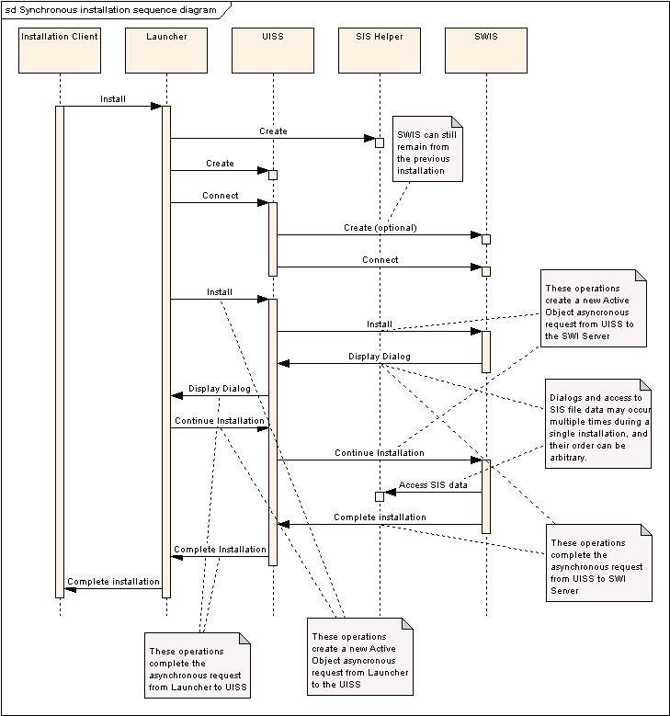

Figure 5-3 Installation sequence diagram

AsyncLauncher vs. Launcher
Asynchronous Installation is implemented using the AsyncLauncher class which has the same interface as the Launcher class. The only difference is that AsyncLauncher is non-blocking, while Launcher is blocking.
AsyncLauncher registers an active object which receives events from the UISS server, allowing other events to be received in the same thread. (See Appendix C in [R5])

UI Support Server

Overview
The UI Support Server acts as a bridge between the SWI TCB components and the UI implementation. This is necessary as TCB components can communicate with the outside world using IPC only. The UI Support Server translates IPC calls into their corresponding function calls on the UI call-back interfaces. The UI Support Server works using a reverse completion mechanism in order to allow the UI dialog functions to be called from the same thread as the installing process.

UML Diagram
The UI call-backs are specified in the MUiHandler mix-in which whose class diagram can be seen in Figure 5-4 UI Call-back Mix-In. UIs must implement this mix-in to interact with Software Install. From SWI point of view these function calls happen on the UISS as driven by IPC requests from the TCB side of SWI.
UISS supports time-out semantics. If the installation client hangs during a UI call back, UISS will wait for a certain fixed amount of time. If the client call back does not return the UISS will shut-down and cancel the installation. This prevents malicious attempts for denial of service attacks on SWI and, at the same time, caters for installation left mid-way unintentionally (See discussion in sections 4.6 and 6.1).
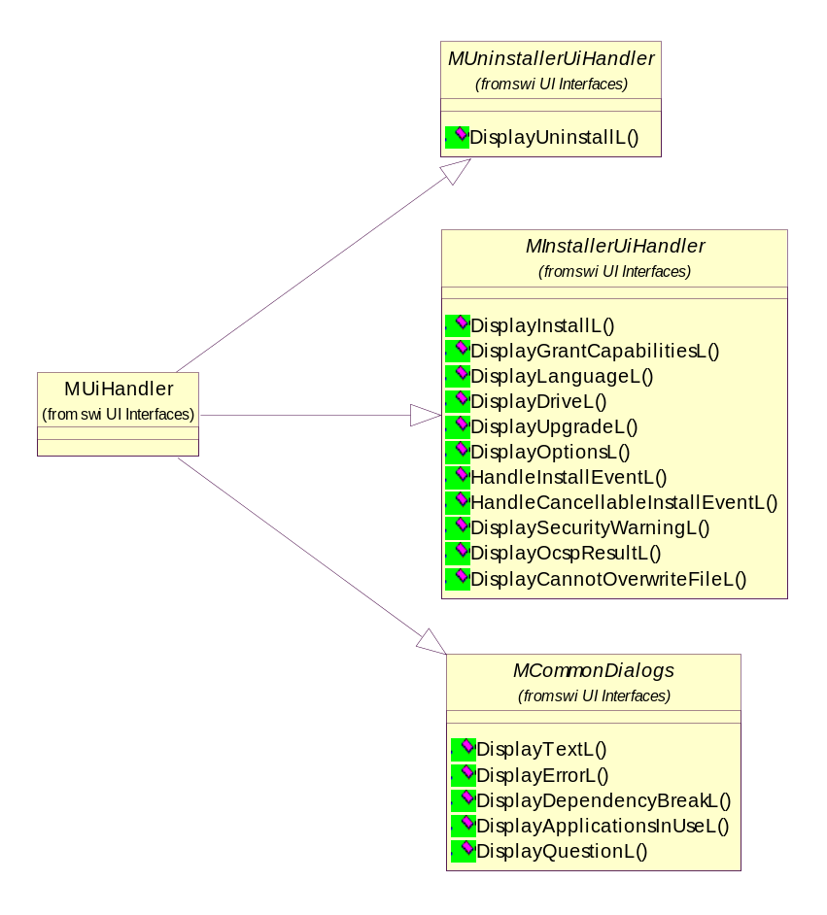
Figure 5-4 UI Call-back Mix-In

Design Unit Behaviour
The user interface which Software Install uses is provided as a Mix-in class as a parameter to the install, restore or uninstall request. This means that we must call these functions in the same process as the application providing the interface. Thus, the UI support server is started in the same process as the application providing the user interface, and is called by Software Install using a client server interface when a dialog needs to be displayed.
The IPC communication between the TCB side of SWIS and UISS is based on the Command design pattern. The appropriate dialog is requested by sending a lightweight command object to UISS. A class diagrams sketching some of the Command objects can be seen in Figure 5-5 Command Objects.
To start the installation, AsyncLauncher/Launcher makes a request to the UI Support Server through the RUissSession class, which uses a client/server IPC call. UISS in turn uses a client/server IPC call to SWIS in order to actually start the installation. Both of these requests are left uncompleted.
When Software Install Server needs to display a dialog, it makes a client/server IPC to UISS using a new session. The UI Support Server then completes the original request made to it by the Launcher, with a code indicating which dialog needs to be displayed, and puts any parameters which need to be passed into a descriptor originally provided. When client UI implementation has displayed the correct dialog it carries out the required marshalling and the recalls the install function using client/server IPC on the UI Support Server. The UI Support server then deduces that there is a dialog display call in progress from the Software Install Server, and then completes this request, marshalling the data as required. This sequence is repeated multiple times over the course of installation, and an overflow protocol is used to increase the buffer sizes used to transfer the data if necessary.
When Software Install server finishes the installation, it completes the request made to it by the UI Support Server. The UI Support Server then completes the original installation request, and the result of the installation is returned to the client.
Please see Figure 5-3 Installation sequence diagram for visualization of UISS participation in the SWI flow.

RUiHandler
Connect()
Close()
ExecuteL()
CUiSupportCmd
CUiSupportCmd()
MarshallArgumentsL()
UnmarshallArgumentsL()
Message()
IpcArgsL()
~CUiSupportCmd()
CShutdownServer
CShutdownServer()
MarshallArgumentsL()
NewL()
NewLC()
ConstructL()
TInstallEvent
CHandleInstallEvent
CHandleInstallEvent()
MarshallArgumentsL()
NewL()
NewLC()
CDisplayInstall
CDisplayInstall()
MarshallArgumentsL()
NewL()
NewLC()
ReturnResult()
CDisplay...
CDisplay...()
MarshallArgumentsL()
NewL()
NewLC()
ReturnResult()
CDisplayLanguage
CDisplayLanguage()
MarshallArgumentsL()
NewL()
NewLC()
ReturnResult()
-iEvent
1
1
1
1
Many more
commands omitted
for the sake of clarity
Figure 5-5 Command Objects

SWI Daemon
The SwiDaemon is a separate process which monitors drives for removable media insertion & removal.
The monitoring is done using notification registration at the F32. Whenever a new drive is being (un-)loaded into/from the device, SisRegistry is notified. This way, SisRegistry can track programs installed to a media card. Also, if there is a specific private directory on the drive, SwiDaemon will attempt automatic installation of all SIS files in there, which have not been previously installed, to support the media card autopropagation and pre-installed application/patches features. In this case, the native installer is launched via AppArc. Please note that AppArc on a real device will invoke licensee UI responsible for installation.
Additionally, SWI daemon allows changing its behaviour via an optional ECOM plugin - SwiDaemonPlugin. Licensee may wish to implement custom behaviour to suppress multiple installation attempts, intercept the launch functionality, perform silent installation etc. This ECom plugin, if present, will replace default behaviour. If there are no implementations of this ECOM interface on the device, then the default behaviour described above will be used.
Also, SWI daemon makes intelligent choices about packages’ installation order, and interfaces with SisRegistry to check whether packages have already been installed. SWI daemon needs to enforce a particular installation order, since the same media card may have both a base package (PA) and its upgrade (PP). In this case, the base package needs to be installed before the upgrade.

SWI Server

Overview
The SWI Server (SWIS) coordinates the installation process. SWIS uses SISHelper for data access, SecurityManager for security-related checks, instantiates the SWI Planner, and passes on the plan to the SWI Processor. The sequence diagram below illustrates the key interactions.

UML Diagram
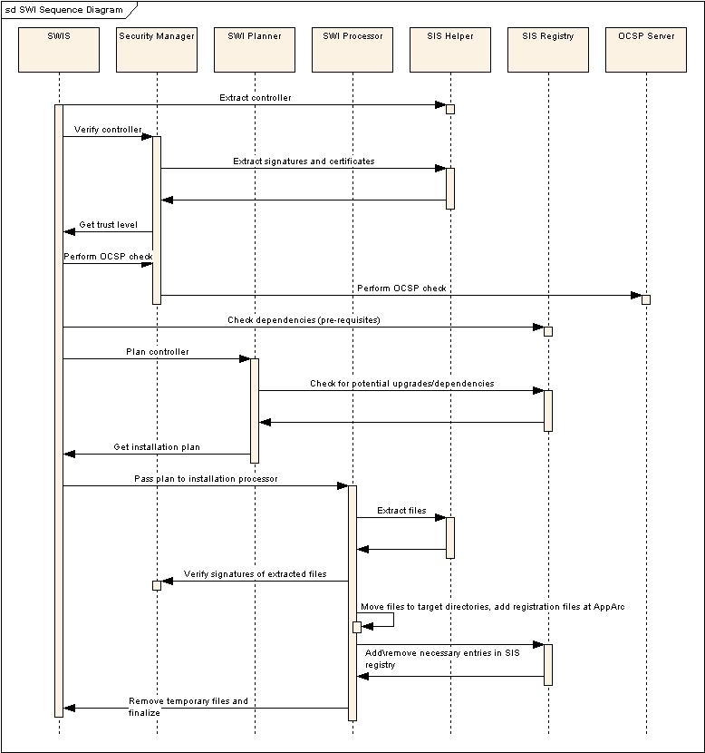
Figure 5-6 SWIS Install Sequence Diagram
The diagram below illustrates the key relationships between core classes in SWI. Please note that this is not the comprehensive class diagram of SWIS, and quite a few details are omitted for clarity. Further details on specific sub-components of SWI can be found in the next sections.

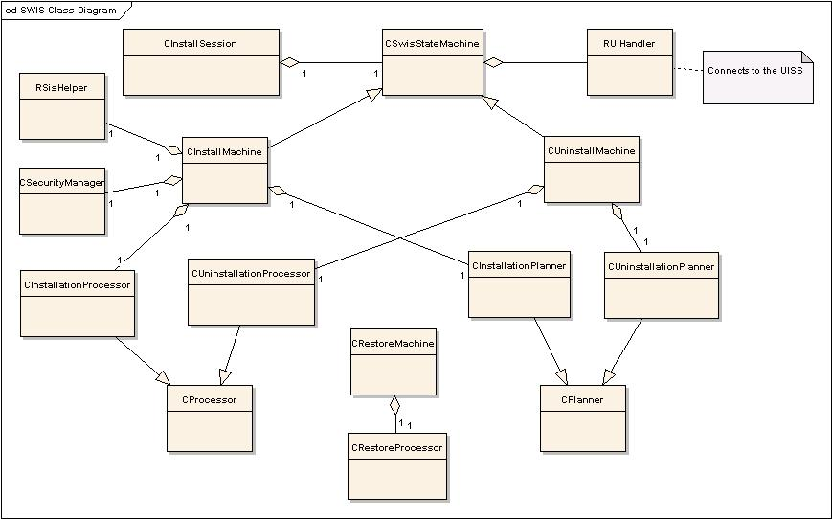
Figure 5-7 SWIS Class Diagram

Design Unit Behaviour
In Figure 5-6 SWIS Install we give an overview of the collaboration between SWIS and the rest of SWI. As we can see the main task of the component is the coordination of the overall installation process.
SWIS supports time-out semantics. If the UISS hangs during a GUI request, SWIS will wait for a certain, fixed, amount of time. It will then shut-down and cancel the installation. This prevents malicious attempts to denial of service attacks on SWI and, at the same time, caters for installation left mid-way unintentionally.
The core of the SWIS is the SWI state machine. The state machine is polymorphic, and has a different implementations for install, uninstall and restore operations. It manages states according to the sequence diagram above, and creates needed objects as needed. The interactions and transitions differ among the state machines, for example, SISHelper is not used during uninstall.
Some of the steps are repeated if multiple controllers are processed (for example, in the case of an embedded SIS file, or dependant SIS files in an uninstall).
SWIS, and most of the server-side components it interacts with, may use the UISS as a client to request information from the user, or to provide feedback during processing.
All state machines are implemented as active objects, i.e. after each state the SWIS thread yields control.

SWI Planner

Overview
As the name implies, the SWI Planner builds an (un)installation plan from a given SISX file. The planner is created by SWIS and given as input the SISX file header (a CController object) to be installed. The planner will examine the SISX file and interact with the user (using the UI Support server) to build an installation plan. User interaction is required as some actions depend on the user’s wishes, e.g. the installation drive, the installation language, etc.
In the case of embedded SIS files, the Installation Planner can get invoked multiple times during the installation – one time for each embedded application. It concatenates results of all invocations in a single installation plan.
The Planner has different implementations for the install and uninstall operations. Restore operation does not need to prepare a plan, as this was already done during the original install operation.
In the case of installation, the Planner takes care of checking whether we are performing a clean install or an upgrade. To accomplish this task it relies on the Installed App Registry (SISREGISTRY). The actual logic of the process is described in the SWI requirements ([R2]).
In the case of uninstallation, the Planner verifies whether additional packages need to be removed.
The Planner encapsulates many of the security checks in SWI, such as eclipsing, overwrites, upgrades, stub files verification etc.
Once the Planner has finished preparing the plan, the SWIS assumes ownership on it, and passes it to the SWI Processor.

UML Diagram
In Figure 5-8 SWI Planner we can see a class diagram of the Installation Planner. The Planner creates a plan object which is a streamlined view of the tasks to be accomplished during the installation.
The planner has access to the parsed SISX controller; this is accomplished using the SISHelper, which provides SIS file parsing.

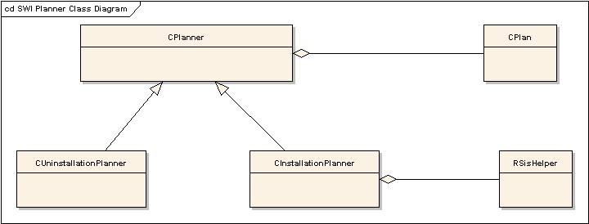
Figure 5-8 SWI Planner

SWI Processor

Overview
The SWI Processor receives a SWI Plan from the Planner, and implements it. Different implementations of SWI Processor exist for installation, uninstallation and restore.
The implementation of the plan consists of:
- Addition/removal of files in the filesystem.
- Registration/deregistration at the AppArc and SisRegistry.
- Executing files, if needed.
- Verifying hashes of the installed files.
- Displaying installation progress.
SWI Processor makes use of Integrity Services to provide transactional behaviour of operations on the filesystem. Since mobile phone can be unexpectedly shutdown much more often than a PC, the installation process must not allow non-graceful shutdown to bring the system into an inconsistent state. The SWI Processor is the most vulnerable component of the SWI because of its lengthy processing time, thus it has to provide strict transactional support for all its operations.

UML Diagram
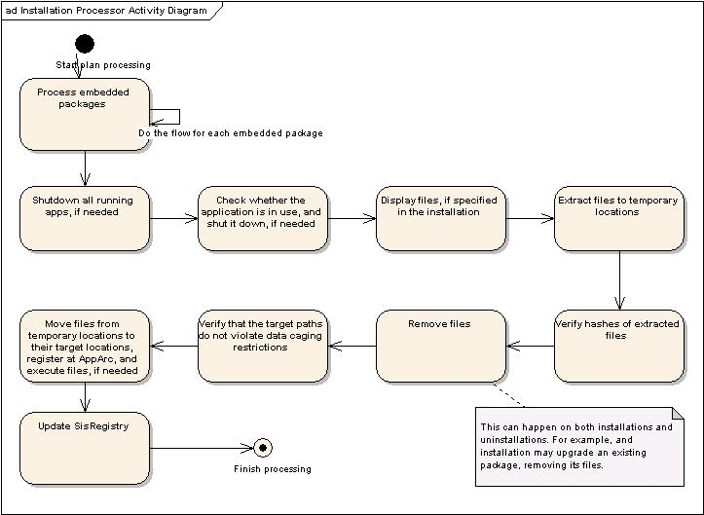
Figure 5-9 Installation Processor Activity Diagram
The diagrams for the uninstallation and restore processing differ somewhat from the installation diagram above. For example, the hash verification and file extractions steps are not used in uninstallation.
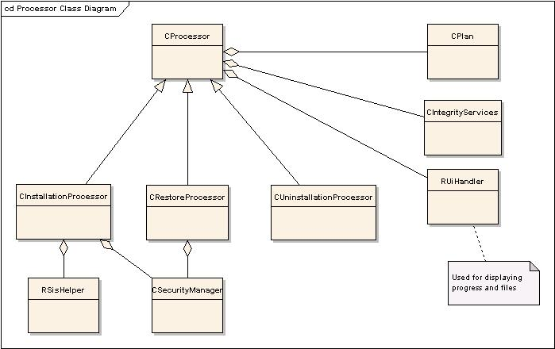
Figure 5-10 SWI Processor Class Diagram

SIS Launcher

Overview
SIS installation files have historically a support for “Run On Install”, Run On Uninstall”. This way, the creator of the installation package can specify custom processing using on of the executable file being installed. In 9.x this functionality has been preserved, but the abilities of the launched executables have been reduced (see [R5]).
This feature is implemented in SWI using SIS Launcher. This component is packaged in a stand-alone executable outside of TCB, and SWIS communicates with it using the usual client-server paradigm.
Files can be run synchronously or asynchronously; when run synchronously the application is terminated after a timeout period if it has not done so already. The asynchronous option is not valid during uninstall or when the file is a temporary file that must be removed before installation ends.
RUNWAITEND applications are not permitted to run longer than a configurable time. In addition, running applications may need to be stopped at uninstall time – forcefully if they do not (or cannot) handle graceful shutdown requests.
SIS Launcher also supplies functionality for shutting down applications, which is used by the SWIS Processor if the application needs to be shut down to continue operation (or a SIS file specified explicitly that all applications need to be shut down). In order to do that, SISLauncher has the PowerMgmt capability.
SIS Launcher accepts connections only from TCB processes to prevent malicious exploitation of its capabilities.

Security Manager

Overview
The Security manager provides a set of cryptographic services for the rest of SWI. Its tasks include:
- Hashing
- Signature verification
- OCSP checks (by delegating them to the OCSP Support Server)
- Capability checking in installed executables.
- Encapsulating the security policy of the device.
The component isolates the rest of SWI from dependencies on the crypto libraries.

Design Unit Behaviour
The Security Manager localises the dependencies of SWI on the Symbian cryptographic infrastructure.
Certificate manipulation is normally accomplished using the unified certstore. The unified certstore relies on the notion of cryptographic token an implementation of its functionalities which is dynamically loaded. Each cryptographic token is an Ecom plugin.
Due to TCB restriction (TCB cannot use the Ecom framework) it is not possible to use the Unified Certstore component to manipulate certificates. The Security Manager bypasses the Unified Certstore and directly instantiates the proper token.
The Security Manager is invoked several times during an installation:
- At the start of the installation it is used to extract the certificate information, and display it to the user for initial confirmation. (CSecurityManager::GetCertificatesFromControllerL)
- During the planning phase to verify certificates and capabilities. (CSecurityManager::VerifyControllerL)
- During the planning phase to launch OCSP revocation check (optional). (CSecurityManager::PerformOcspL)
- To verify hashes when the files are being extracted and installed. (CSecurityManager::VerifyFileHash)
- To calculate hashes when creating a stub SIS file. (CSecurityManager:: CalculateHashLC)
Security Manager supports multiple signatures certificate chains in a package (REQ2679.1). The security manager checks and assigns executable file capabilities as specified in the corresponding certificates (REQ2681.3.4.3).
Security Manager can also be used by the SWI Registry in the cases where an existing package is verified after it has been already installed. A package verification can be launched either manually by the user, or by the loader in specific cases.
Also, the CSecurityPolicy class provides parsing of the swipolicy.ini file which includes customizable security settings. These settings, and therefore, this class, are used throughout SWI.

SISHelper Server

Overview
The SISHelper Server provides SISX parsing and data access functionality for the Software Install Server. It is located outside of the SWI TCB block for several reasons:
- It uses decompression libraries, which have low trust level, and thus cannot be loaded in a TCB process.
- The size of TCB should be as low as possible, and SISX parsing and data access functionality does not require any protected directories,
It is instantiated by the UISS Server before it connects with the SWI Server. It has a protected name (and thus, the ProtServ capability). It does not support concurrency, and can support only one installation operation at a time. It is used only for the installation operation by the SWI Server, and is not needed for uninstallation or restore.
It encapsulates all SISX parsing knowledge in SWI.
As an underlying data abstraction, it uses data providers which supply it with raw data for parsing.

Design Unit behaviour
The SISHelper server is a standard server, and is started in the same process as the installing application. It implements various functions. A subset of these functions is listed below.

- SISControllerLC – This gets the controller of the SISX file which is being used in the current installation.
- ExtractFile – This gets a file from the SISX file which is being used in the current installation.
SISHelper server is constructed and launched using information which is passed from the Client UI Implementation. It uses it as the low-level data source abstraction to read the SISX file from.
SISHelper makes use of the SISfile binary component which provides it with parsing helpers.

Data Provider Framework

Overview
The purpose of the Data Provider Framework is to enable seamless addition of data sources for SISX files. Typical data sources types include a compressed file, a regular file, or a file handle.
Data Providers are either instantiated by the Client UI implementation or by the SISHelper Server.
Data Provider Framework consists of several binary components:
- SwiDataProvider
- CafDataProvider
- SISFile

UML Diagram
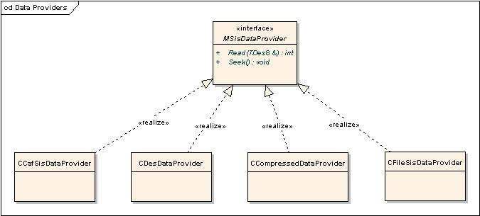
Figure 5-11 Data Providers Class Diagram

Design Unit Behaviour
All implementations of MSisDataProvider provide means of reading the data via the key interface calls Read and Seek.

SwiDataProvider
Contains CDesDataProvider and CFileSisDataProvider. The former provides data from a descriptor (i.e. when data has already been loaded into memory), the latter provides data from a file system.

CafDataProvider
Contains CCafSisDataProvider. Provides data from a DRM-protected content. Uses the CAF internally.
The purpose of this module is to encapsulate handling of DRM-protected installation packages, so that SisHelper is unaware of the protection layer. For protected files, the most common DRM scheme is OMA DRM. CAF detects the protection scheme by querying the registered CAF agents (implemented by licensees).
If the file is not protected, then the default filesystem agent is used, and the behaviour of CafDataProvider will be similar to the one in CFileSisDataProvider.
Otherwise, the corresponding CAF agent (e.g. OMA DRM) decrypts the file, and CafDataProvider passes the decrypted data back to SisHelper.
CafDataProvider is used whenever the DRMEnabled flag in swipolicy.ini is set. Otherwise, SwiDataProvider classes are used.

SisFile
Contains CCompressedDataProvider. Provides data from a compressed content. Aggregates a non-compressed MSisDataProvider implementation (e.g. CFileSisDataProvider). Please note, that in the case of compressed SIS files, the contents are first extracted to a temporary location, since the data provider is not in TCB, and cannot write to data caged directories.

Licensee Defined Data Provider
In addition to the data providers supplied by Symbian, a licensee can implement his own incarnations of MSisDataProvider (for example, to add another compression scheme).

Integrity Support

Overview
Software Install is required to keep the device in a consistent state even in the occurrence of failures, e.g. empty battery, flash card removal, etc. Integrity Support is the SWI component providing the mechanisms to guarantee device consistency regardless of failures occurring during software install. If a software install process (install, restore or uninstall) is interrupted then that process is reverted, returning the device to its original state with no orphaned or missing files. The original state is restored even when multiple consecutive failures occur during recovery.
Also, Integrity Support is used by the SIS Registry for its own registration files’ management.

Design Unit Behaviour
CIntegrityServices object is constructed both for each installation by SWIS, and on device start-up by SisRegistry. Integrity Services does not distinguish between installation, uninstallation or restore, and is aware only of different filesystem operations, such as remove, add or create temporary.
Internally, Integrity Support manages journals on the file system, effectively adding journaling support for Symbian FS. In order to support successful rollback in the case of failure, deleted files are only copied to a temporary location, and get completely deleted only in a successful commit.
Failed transactions, i.e. cases where the phone has been shut down before the installation was committed, are rolled back. Since a CIntegrityServices object is constructed in boot time by SisRegistry, the roll back operation occurs automatically after the device has been powered up.
Transactions which have failed during commit are rolled forward, i.e. all pending operations are completed.
After successful completion of installation (or roll back/cancel), all journal files are deleted.
As a useful side-effect, journals created by CIntegrityServices are used as the underlying format for backup/restore.

OCSP Support

Overview
Due to platform security restrictions, we cannot carry out the OCSP checks in Software Install Server, since processes with TCB capability cannot load the HTTP library Dlls.
To facilitate OCSP checking by Software Install, the OCSP library is split into two parts. One part creates the request and decodes and verifies the response, while using the transport component in order to make the actual request.
A new transport is provided, which uses IPC to forward all the requests onto a server in a different process. The responses are then passed back where they can be decoded and verified inside Software Install Server.

Diagram
COcspSupportTransport provides an implementation of the MOCSPTransport interface which forwards its calls onto the OCSP Support Server, provided in OcspSupport.exe. This server is started automatically as needed.
IPC Call
Ocsp.dll
OcspSupportClient.dll

OcspSupport.exe
Process Boundary
Figure 5-12 – OCSP Dlls and Executables

Design Unit Behaviour
A new transport is provided, which uses IPC to forward all the requests onto a server in a different process. The responses are then passed back where they can be decoded and verified inside Software Install Server.
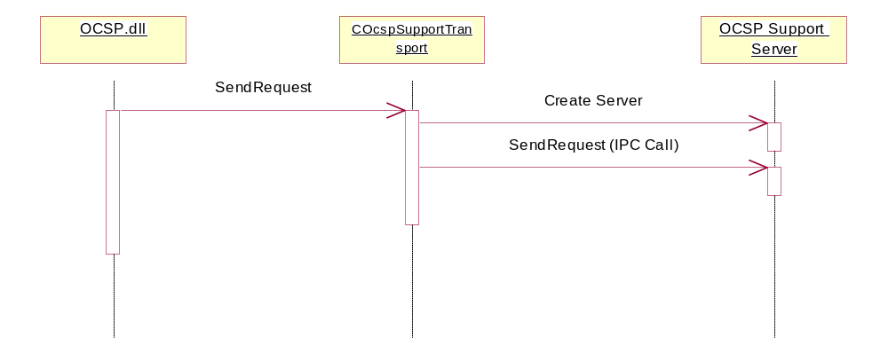
Figure 5-13 – Calls resulting from the OCSP engine asking the transport for a request

SisRegistry

Overview
SisRegistry component manages and provides information about the currently installed native applications on a specific device. It consists of a SisRegistryServer and SisRegistryClient. The server is implemented as a CPolicyServer operating in a separate process with TCB+ReadDeviceData+WriteDeviceData capabilities. The TCB capability is used for write access to \sys\install\registry, where the registry files are kept, and ReadDeviceData and WriteDeviceData are needed by definition, since the registry of installed applications is the key part of the device data.
SisRegistry polices access to the different interfaces:
- The ability to get information for a specific package is open to all clients.
- The ability to get read-only information without supplying a specific package id is open to clients with ReadUserData.
- Requesting a security check for a specific package requires WriteUserData and NetworkServices.
- Modifying, adding and removing entries requires TCB (i.e, SWIS).
- Mounting and unmounting registry on a specific drive is allowed only to SWI Daemon.

UML Diagram
To access SisRegistry information the client links against the SisRegistryClient.dll, which provides read-only and writable specializations of RSessionBase and RSubSessionBase classes as shown in Figure 5-14. For brevity only limited number methods are shown for each class.
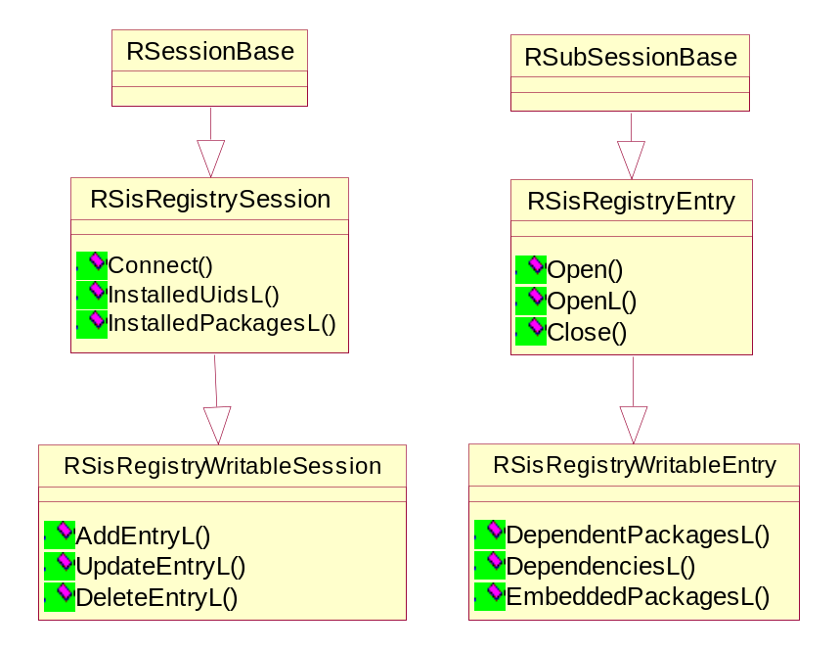
Figure 5-14 SisRegistry Client Interface

Design Unit Behaviour
SisRegistry component should provide client support irrespective of whether SWI Server is running or not. It should be able to serve more than one client at a time. It should also be easily verifiable and have a thin interface, as it forms a part of the TCB. This is why it has been created as a separate process, which is started automatically on boot. A sketch of its interaction with clients is shown in Figure 5-15.
The IPC communication between clients and server are synchronous. In this way client is guaranteed to get the most up to date information. The design is also based on the assumption that at any one time only a limited number of clients would make requests, so that the overhead is acceptable.
To start the server, a client connects to the registry using RSisRegistrySession. SWI Server uses RSisRegistryWritableSession API which further specialises the registry session functionality. At the session level clients can request only general information e.g. whether an application with a specific UID is installed. However to access application specific information the client opens a subsession using either an UID or a package.
The SisRegistry server maintains registry information in /sys/install/registry directory on system drive C. Each native application is distinguished by its own UID number and its respective information is stored in a directory denoted by that UID as a hexadecimal number. There the SisRegistry Server stores the registry file. Also, there the Integrity Services stores the journaling information. As a reminder, SisRegistry uses CIntegrityServices during mutating operations on the registry.
For augmentations the registry maintains separate registry files and controllers sets positioned in the same directory. This is imperative as should be possible to uninstall augmentations separately from the associated application. The distinction is achieved by different file names. Otherwise, the file structure is identical.
For each installed application, SisRegistry stores its trust level. Typical trust levels are: ENotSigned, ETrusted, EUserAccepted, etc. This trust level is used in later decisions by SWI (for example, a trusted application can overwrite files of a non-trusted one).
To maintain a reasonable degree of responsiveness, the global information, which would be requested through RSisRegistryWritableSession is cached in RAM, with the intention to minimise the disk access. When the server shuts down, this information is stored in a binary file named backup.lst.
When the server starts again it checks whether the backup file exists and loads it. Otherwise, it assumes that an error has occurred and updates its internal information by reading all registry files. The server also processes the controllers stored on Z drive in sys/install.
In the case when specific SisRegistry entry information is requested using RSisRegistryEntry or RSisRegistryWritableEntry, the SisRegistry Server opens the specific registry file in shared read access mode. The file is closed when the related subsession is closed.
SisRegistry Server is able to discover previous installations on media cards and update its internal state, when notified by the SWI Daemon.
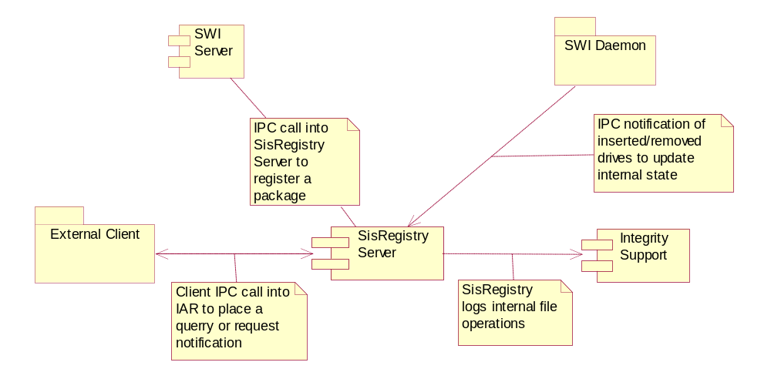
Figure 5-15 SisRegistry Relationships

SisRegistry and Secure Backup
One of SisRegistry’s clients is Secure Backup. It uses SisRegistry’s information in order to get packages’ file lists and identify which files belong to which package. Apart from that, Secure Backup does not use any of the SWI functionality.

Scenarios
This section details processes and use cases which lie outside of the main path.

Cancelling an Installation
Installation can be cancelled by the UI, this can happen for various reasons. Typically the user would click on cancel when a dialog is displayed.
There are two main scenarios for cancellation: during a UI call-back, typical of device based UI implementations (Figure 6-17 Cancelling Installation During a Call-back) and outside an UI call-back, typical of PC connectivity software, e.g. due to a lost connection to the PC (Figure 6-16 Cancelling Installation Outside a Dialog Call-back). The latter can only occur when an asynchronous installation is used.
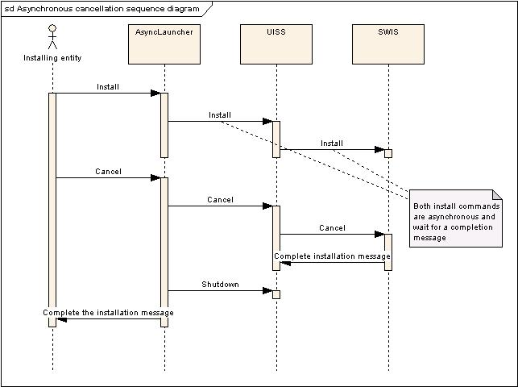
Figure 6-16 Cancelling Installation Outside a Dialog Call-back

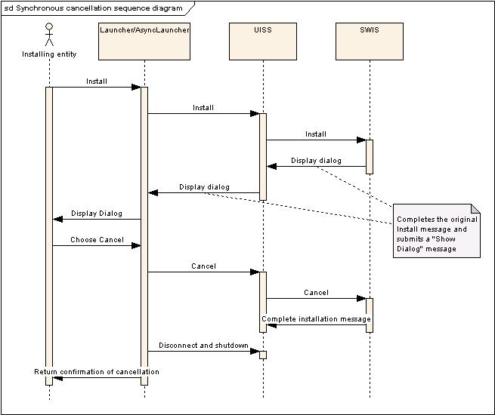
Figure 6-17 Cancelling Installation During a Call-back

Uninstallation
Uninstallation behaves similarly to installation, with the exception that SisHelper is not used which modifies slightly the general flow. The diagram below illustrates the behaviour of SWI during in uninstallation.
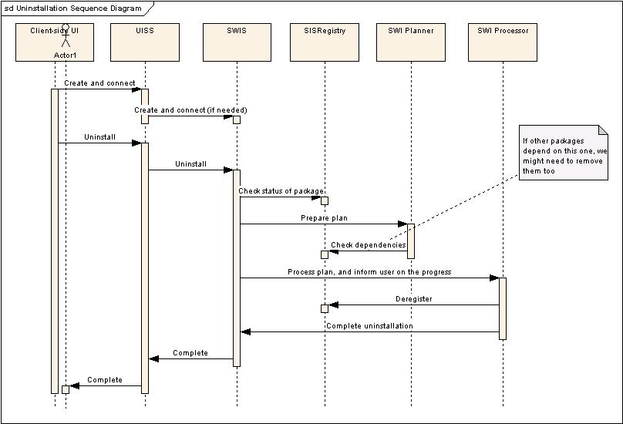
Figure 6-18 Uninstall sequence diagram

Further Information

References
No. | Document Reference | Version | Description
[R1] | “UML Explained” |  | by Kendall Scott  (http://www.amazon.co.uk/exec/obidos/tg/stores/detail/-/books/0201721821/toc/202-4456432-1159001)
[R2] | Security Subsystem Functional Description |  | \common\generic\master\security\documentation\SGL.GT0235.201_Security_9.2_Functional_Specification.doc
[R3] | Security Subsystem Architectural Description |  | SGL.GT0255.265_Security Subsystem Architectural Description.doc
[R4] | SISX File Format Specification
[R5] | “Symbian OS Platform Security”, Chapters 2 and 8

Glossary
The following technical terms and abbreviations are used within this document.
Term | Definition
SWI | Software Install
SWI Operation | Install, uninstall or restore
SWIS | Software Install Server
TCB | Trusted Computing Base
SISREGISTRY | Installed Native Applications Registry
SIS | Legacy Symbian package format
SISX | New Symbian package format (SIS eXtended), it caters for the new platform security requirements.
UISS | UI Support Server. The bridge between the UI implementation and the TCB side of SWI.
OCSP | Online Certificate Status Protocol. The protocol checks the status of a given Certificate and returns either “current", "expired," or "unknown." It supersedes Certificate Revocation Lists (CRLs)
UID | Unique ID

All references to REQ ids can be followed in [R2]
Specifically, all interactions from non-TCB to TCB components cross process boundaries.
The registry is stored under \sys to prevent processes with AllFiles from modifying the registry information. TCB is required for write access to \sys, while only AllFiles is needed for write access to \private. See [R5]
Please note that only single copy of the DLLs is loaded by the kernel.
Originally, TrustedUI capability was intended to protect sensitive dialogs, such as password input. Its purpose was later modified to protect installation requests.
Currently used by uiadaptorscripts for automatic testing and by the command-line interface utility.
Used by all GUI clients
Another required security functionality here is being provided by the Symbian Loader, which checks the hashes of the executable before launching it.
It is also used by SWI to disallow simultaneous operations.
Policed by SWI Server
FileSystem Server
<Daemon’s private directory>/mediachange
Application Architecture – a module which is responsible for displaying and launching native installed applications. One of them is the installer client itself.
The hash verification occurs only here, as doing it earlier would require reading the whole file twice, and this would decrease user experience.
Content Access Framework
As a reminder, the TCB capability does not implicitly include any other capability to prevent hierarchical structure and complexity in the security model.
For that, it has both ReadUserData and AllFiles capabilities
The “Secure” word comes from the verification done during restore – if an executable file was modified offline, it won’t be installed during restore, as its hash won’t match with the one stored in \sys\hash

